(Appendix A)
PO BOX 3303
MTUBATUBA
3935
15 JANUARY 2024

Dear Sir
RE: PERMISSION TO CONDUCT RESEARCH STUDY

I am Happiness Thulubheke Zwane studying at Regenesys for Master of Public Management Degree. It an obligation that a student should prepare empirical research before completing the Degree, hence I am applying for the permission to conduct the research from you. The title of the research is:
Evaluating perceptions and implications of teenage pregnancies in a rural school within uMkhanyakude District, KZN, SA

Therefore, I kindly request your permission to interview the following school community persons: educators, non-teaching staff, parents, SGB, Traditional leaders and learners who will voluntarily participate in the research.
Approving my request will be greatly appreciated. For more information, I can be contacted on: 0826117026 or by email thulubhekez@gmail.com.

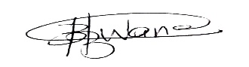
Happiness Thulubheke Zwane

